Shannon Foreman

Strategic Management in Dynamic Environments (MGMT 690)

Scorecard Strategy

Colorado Technical University

June 7, 2017

Balances Scorecard and Global Strategy

Balanced scorecard refers to a management system that is used by the management of companies for several purposes. Balanced scorecard is an important tool for measuring and monitoring how the company is progressing towards the strategic goals. The Balanced scorecard also is used by the management to create priorities for products, services as well as projects. Projects as well as products and services need to be carried out in priority order. The balanced scorecard ensures that, priority projects as well as products are carried out first, before projects and products less in priority. The Balanced scorecard also ensures that, the daily tasks for all the employees are executed according to the strategies set. Moreover, the balanced scorecard ensures communication of strategies to employees so that the workers have a clear picture of what their targets are.

Four Perspectives of The Balanced Scorecard

1. Learning and Growth Perspective

The learning and growth perspective is concerned with capabilities of the employees of the organization. The management should focus of ensuring development of the capabilities of the employees in the organization. The employees should be empowered to get more skills and knowledge. They should be given an opportunity to advance in their career. This will also improve the labor productivity. The managers should be evaluated on achievement of this perspective through measurement of employee productivity, employee retention and employee satisfaction. The employee satisfaction for instance is an important indicator of the morale of workers for the improvement of responsiveness, customer satisfaction, quality of output as well as productivity (Tjader, May, Shang, Vargas & Gao, 2014). The managers should conduct employee satisfaction survey by observing employees while working, interviewing them and giving them surveys documents. Employee retention shows the capability of the organization to maintain its human capital to provide services for the organization for long. The employee retention should be measured to indicate the extent of employee empowerment. Employee productivity is also an indicator of output per employee. The management should measure the employee productive as an indicator of employee learning and growth.

1. Internal Business Perspective

In the internal business perspective, the management is required to establish the internal processes that are critical to the company and that it must perform well in. These are the activities that make the organization capable of delivering the core values and therefore attracting and retaining customers and therefore the market share as well as giving proper financial returns to shareholders. There should be sufficient control in the organization so as to enable reliability and consistency in product and service quality. To attain consistent high performance, the inputs must be actively controlled (Tjader, May, Shang, Vargas & Gao, 2014).

1. Customer perspective

The management should identify the customers and market segments that are targeted and where the company will compete and then formulate best measures to be adequately competitive. The attainment of this perspective is measured through indicators such as market share, customer profitability, acquisition of new customers, customer retention as well as customer satisfaction. The perspective should also measure the values that are geared towards delivering to the targeted customer and market segments.

1. Financial perspectives

The financial perspective requires the use of measures of financial performance such as return on investments and Net profit to measure progress (Rabbani, Zamani, Yazdani-Chamzini, & Zavadskas, 2014). These financial measures can be used as a basis for comparing between different companies. Funding organizations and institutions depend heavily on financial performance in the decision-making process on whether to advance funds to a company. the management is therefore supposed to use such financial measures to determine the success of the organization. Below is a diagram showing the interlink between the four perspectives.

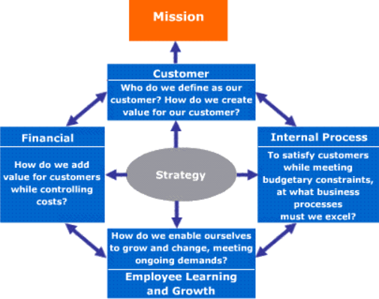

Strategies That Would Be Good for John and Deborah

John and Deborah Corporation need a global strategy. The global strategy involves establishing shops in other parts of the world. This strategy therefore expands the market share of the company. with new customer regions, the sales of the company would increase and therefore increased growth and expansion. There are several strategies that are important while pursuing the global strategy.

1. Adoption of a clear product strategy- while pursuing global strategy, it is important for the company to adopt a clear product strategy. it is important to design a product that allows expansion into the global market in terms of quality and customer reception (Peng, 2016). The products should first be tested in the United States before they are tried in in the global market, such as France, Germany and the United Kingdom. This is to identify and incorporate needed changes.
2. Profit plough-back- while pursuing the global strategy, it is important to ensure profit plough back. The management should reinvest the earnings so as to expand the size of the product portfolio. This is because, the global market is full of competitors and a bigger sized firm would offer more competition than a small sized one (Peng, 2016).
3. Partnering with other firms- the company may also consider partnering up with other firms, offering the same products in the market. This minimizes risks and increases overall profitability (Peng, 2016). Partnering is also crucial since John and Deborah would utilize the distribution channels of the already established firms to penetrate into the global market.

The importance of having more than one strategy in mind when pursuing global expansion

While pursuing the global strategy, having more than one strategy in mind is important for diversification. This is because, if one strategy fails, then the management would try the others. it is safer to have more than one strategy, than having a single strategy. a single strategy could fail. If one fails, other act as alternatives.

**References**

Peng, M. W. (2016). *Global business*. Cengage learning.

Rabbani, A., Zamani, M., Yazdani-Chamzini, A., & Zavadskas, E. K. (2014). Proposing a new integrated model based on sustainability balanced scorecard (SBSC) and MCDM approaches by using linguistic variables for the performance evaluation of oil producing companies. *Expert Systems with Applications*, *41*(16), 7316-7327.

Tjader, Y., May, J. H., Shang, J., Vargas, L. G., & Gao, N. (2014). Firm-level outsourcing decision making: A balanced scorecard-based analytic network process model. *International Journal of Production Economics*, *147*, 614-623.